**LO SGUARDO FA SCARTO**

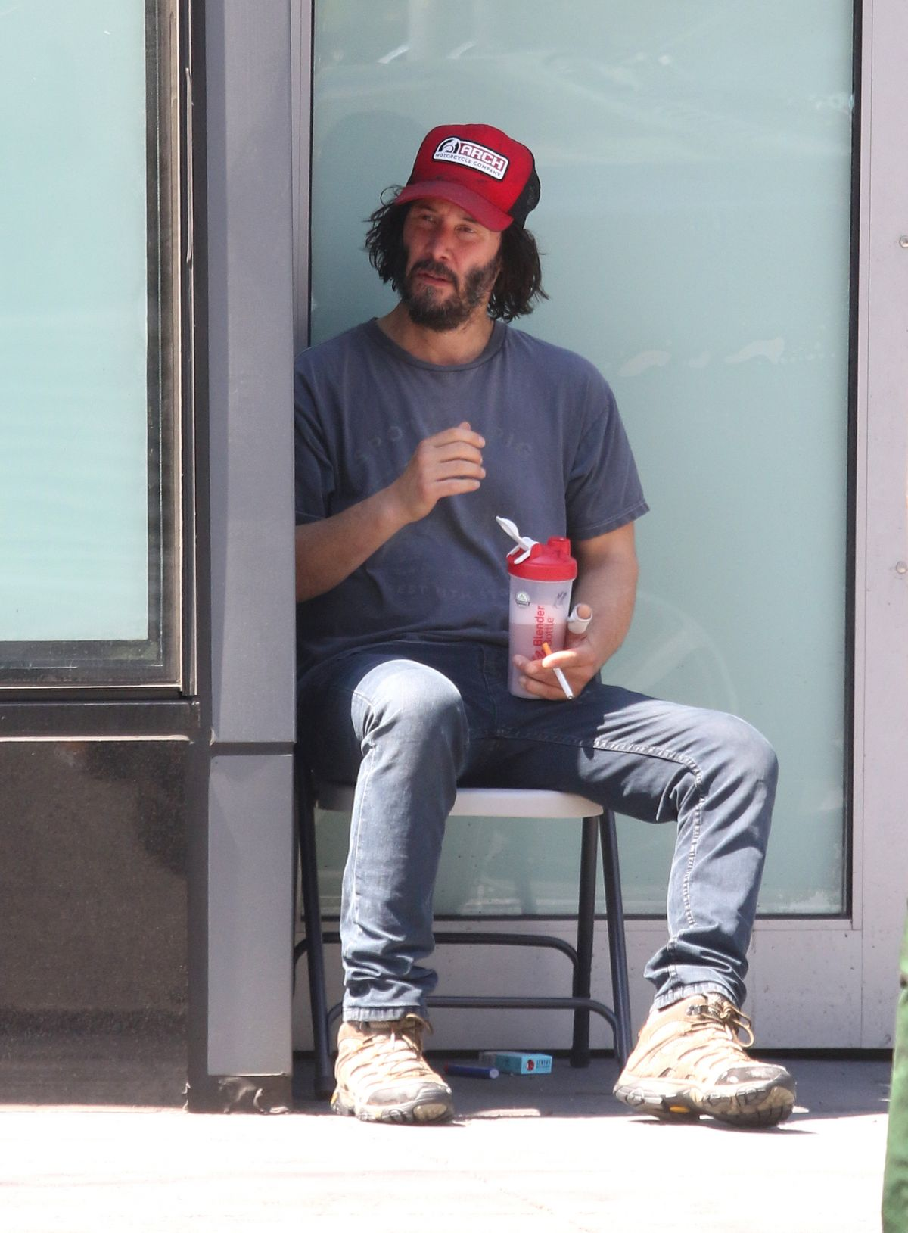

**KEANU REEVES**

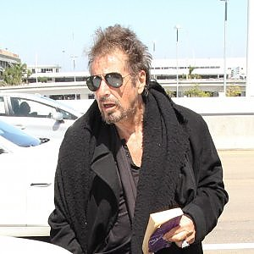

**AL PACINO**

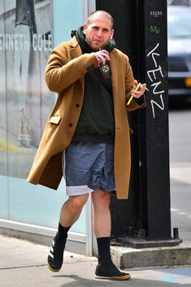

**JONAH HILL**